# Laravel Note

Advanced notes

Dummy tables (Many to many relationship)

To store the data in the dummy table, Laravel provides the attach() function.

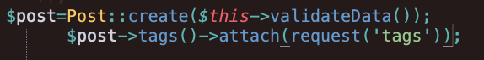

In here tags is an array with the name of tags.

# mail

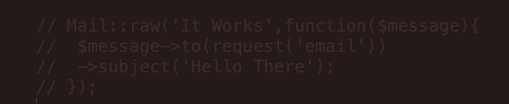

Sending the text file.(raw)

Sending html file with view(manual custom HTML)

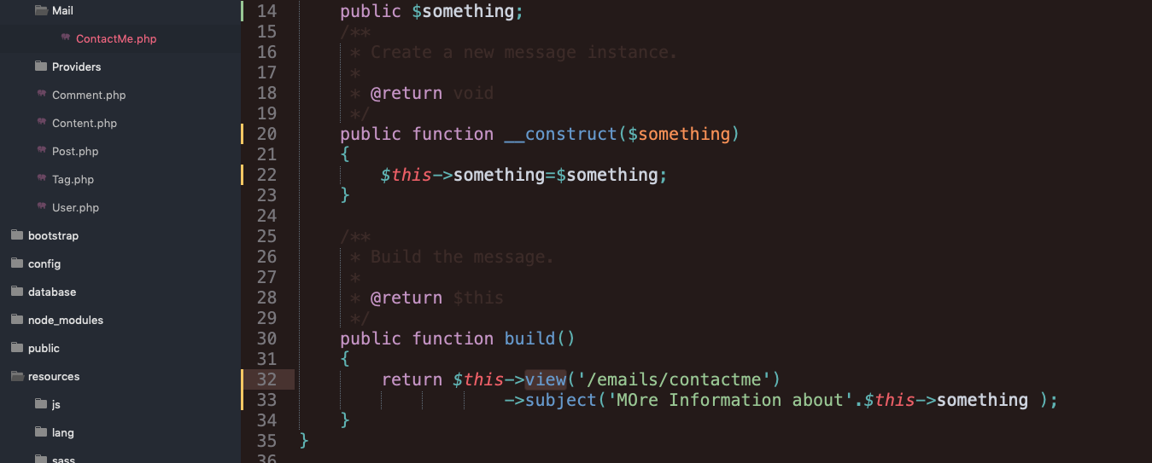

With the command

Php artisan make:mail ContactMe

Sending HTML with mark down (Using the Laravel supported Template HTML)

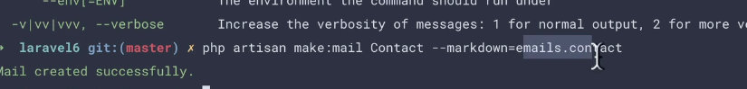

To customize the items



# Notification

Same with mail with better api

Use when we expect a response



Then Customize

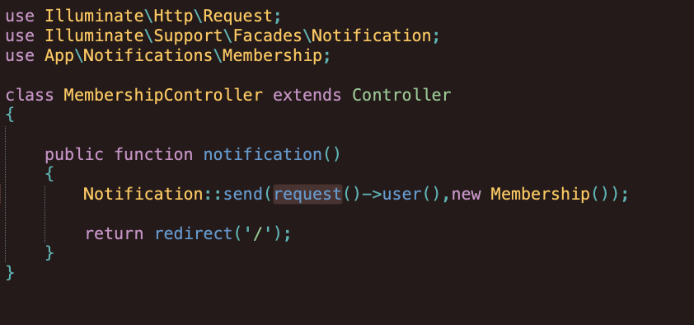

Or request()->user()->notify(new Membership());

# Authorization

@endcan

@can('delete_post',$post)

In this code, define_post is a key or name or variable and $post is the parameter or the object that will be authorized.

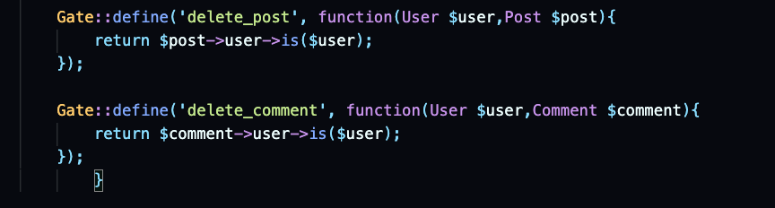

In directory App\providers\authen…. . we have to make the authorization by gate method.

Define the object that is involved in the authorization along with the key.

And boom completed.

There is another way of doing this.

Making Policy this would also serve the same purpose

Php artisan make:policy Name

# Uploading files Aka Images

To upload the image we can use store method that the Laravel originally provided.

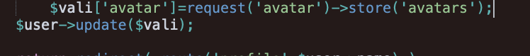

Then the data will be stored in the storage folder but not public which means we cannot access from the website.

So we have to change the directory in .env file



Then to link with the public folder the following command do the work.

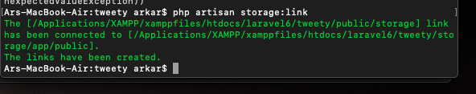

Now finally the diectoy is correct. And the final step is to asset to the file .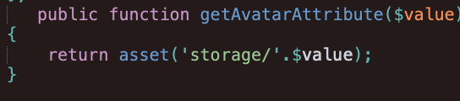

We can now call the avatar by $user->avatar.

# Update

In updatewe have to use the patch method.

And laravael provided function called update()

$user->update()

For the password, to get the hash password and stored set in the User File

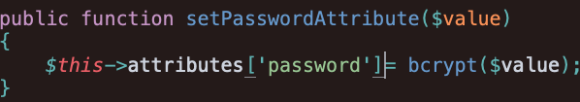

This will do the work.

For further updating fields you can use the method PUT PATCH.

To get the profile with the name

Add getRouteKeyName() function to the User.php.

Then it will work.­­­

Stoping the aphache web server

Sudo apchectl stop